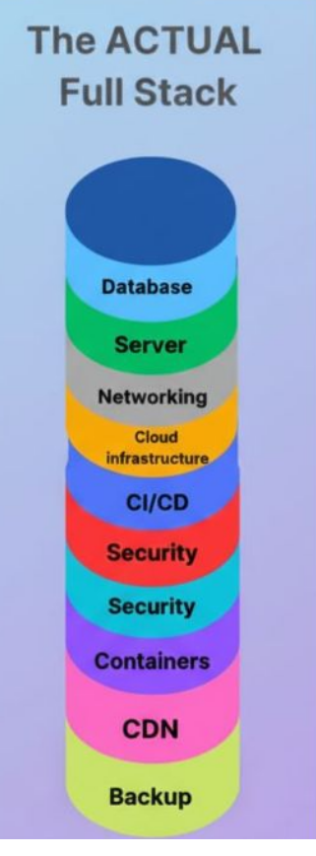

#)how can I initialize a node js app for the backend:  
inside a file use : npm init -y this will create a package.json file to manage dependencies.

#) how can insatll packages :

We can use npm ,after that we can write the name of the dependencies.

#)API:  
here we till now haven’t created the frontend just created the node backend which will receive the request and the api is the waiter which will cater all the requests by the frontend.

Since you don't have a React frontend to send data yet, you'll use a free tool called **Postman**. It's an app that lets you send requests to your API and see the responses.

In this context, the **API** (Application Programming Interface) is the set of rules and URLs you are creating on your backend server.

Think of it like a waiter at a restaurant:

* **Your Backend Server (index.js)** is the **kitchen**. It does all the work (like hashing passwords and talking to the database).
* **Your Frontend (React App)** will be the **customer**. It needs to ask the kitchen for things (like "register this user" or "get me all the projects").
* **The API** is the **waiter and the menu**.

The "menu" is the list of endpoints you create, like:

* POST /api/register
* POST /api/login
* GET /api/projects

#)Modules used for security(bcrypt ,module which does hashing of the passwords):  
**npm** stands for **Node Package Manager**. Provider of different node packages.

#)running a react app:

Npm start.=for frontend

Node index.js=for backend ,do these in two diff terminals.